Minutes
Chisholm Road Prison Project - Community Advisory Group

MinutesAgenda
Chisholm Road Prison Project - Community Advisory Group
Meeting details
Meeting title: | Community Advisory Group | No: | 10
Date: | Wednesday 9 October 2019 | Time: | 4.00pm to 6.00pm
Location: | Marngoneet Correctional Centre (Boardroom Administration Building), 1170 Bacchus Marsh Road, Lara
Attendees
Community Advisory Group members: Councillor Kylie Grzybek (Deputy Chair), John Brne (community member), Jeff Cahn (community member), David Withington (community member), Marylyn Pettit (community member) and Andrew Reaper (Assistant Commissioner, Corrections Victoria).
Additional: Mike King, Corrections Sector Lead (John Holland), Peter Chater, Project Director (John Holland), Kavan Applegate (Guymer Bailey), Andrew Bradley (ICN), Alex Wigmore, (Senior Project Manager) and Louise Baring (Communication Manager).
Apologies:
Justin Giddings (Chair), Corrina Eccles (community member), Councillor Anthony Aitken, Barry White (community member), Corrina Eccles (community member), Michelle Wood (Executive Director, Barwon South West Region) and Rod Wise, (Deputy Commissioner Corrections Victoria).
Meeting overview
Previous minutes
Previous minutes were endorsed.
Design overview
A presentation was given on the progress of the design of the new prison, with images provided on the design of the Gatehouse, Visitor centre, Health centre, Operational support centre, Education and programs area, Cultural centre and Accommodation areas.
A question was raised on the visual impact of buildings from Chisholm Road. The architect explained that with the combination of the height of the buildings and the perimeter wall, there will be little to no visual impact or visibility of buildings from Chisholm Road.
Managing contractor presentation
John Holland gave a presentation on the project and outlined that they will be building:
  - 1248 beds to accommodate sentenced and remand prisoners within separate mainstream and protection communities.
  - Gatehouse, Health centre, Industries (Protection & Mainstream), Kitchen & Laundry, Education & Programs, State-wide Services Building and Security & Emergency Services Group Building.
John Holland outlined that the project will generate a range of local opportunities including;
  - More than 900 indirect and direct jobs to the Greater Geelong region throughout the lifespan of the Project.
  - More than 650 ongoing jobs will be created when the facility becomes operational, including prison officers, psychologists, administration, maintenance staff, and allied health professionals.
  - Estimated economic benefit of at least $173 million for the local area.
John Holland outlined that construction will take place in two stages which included early works in December 2019 and all remaining works commencing in 2020.
Traffic management and specific truck routes
John Holland outlined a specific traffic management route for all vehicles entering and exiting the site. The route follows the preferred route stipulated by the Community Advisory Groups, minimising impacts on the local community (image below outlines the route).
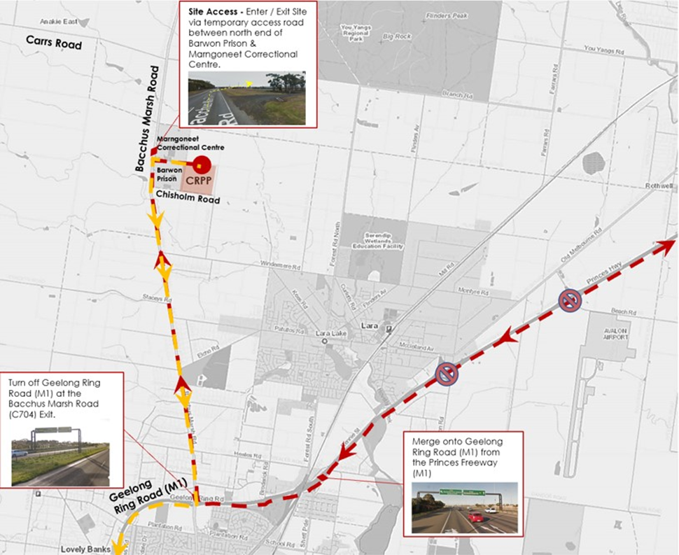

Industry briefing event
An industry briefing will be led by the department in partnership with the project’s managing contractor John Holland and the Industry Capability Network (ICN).
ICN offer services that support local industry participation, local content considerations and assist with the project procurement process. They ensure local subject matter experts are given full and fair opportunity to compete for government contracts while achieving value for money.
ICN has established a gateway page to provide information on project opportunities and work packages, and manage EOIs. Through this page an Industry Advisor (IA) who can help businesses and individuals understand how to bid.
ICN representative outlined key details of the upcoming industry briefing event including;
- To be held at Rydges Geelong, 4- 6pm Tuesday 15 October 2019. It will feature presentations from key project leaders, a panel Q&A and a networking opportunity.
- Suppliers and subcontractors from the Greater Geelong region and Victoria interested in working on the construction of the new prison are being encouraged to attend the information session.
- A similar event was successfully held for new youth justice centre in October 2018.
All group members were invited to attend at their discretion and also to help promote the event within their networks.
The department agreed to provide a debrief of the Industry Briefing at the next Community Advisory Group meeting.
Project Update
Design
- The design of the new prison is in progress, with drawings being developed to issue for construction level of detail.
Access Road
- It has been identified that new access road for the prison impacts on Golden Sub Moth (GSM) Habitat, which is identified as a protected species in the Environmental Protection and Biodiversity Conservation Act (EPBC).
- The engineers have revised the design of access road and the construction method to protect the 400 meter section of the affected road.
- To assist managing access to the site, the department has made an application to the City of Greater Geelong Council to have temporary access to Chisholm Road.
- Stringent controls will be in place to ensure contractors meet the planning approval conditions i.e. no right turn out of Chisholm Road.
Managing Contractor Procurement
- The Managing Contractor Procurement has now been complete.
- John Holland are accountable for finalising the designs and constructing the prison.
Signage
- VicRoads has approved the relocation of the signage on the Princes Freeway. The department has engaged a contractor to undertake the works.
Traffic Management
- John Holland has documented a Traffic Management Plan with the truck routes to exit the Geelong Ring Road at Bacchus Marsh Road.
Planning
- The Correctional Facility Plan has been submitted to the Department of Environment, Land, Water and Planning. The department is responding to the following queries:
  - Waste management
  - Signage within the prison precinct
  - Soil contamination
  - List of changes to the CFP that Council reviewed, to what was submitted to DELWP.
Emergency Management Planning
- No further meetings have been held since the previous CAG, although the project team are continuing to liaise with VicPol and Ambulance Victoria regarding their infrastructure requirements in the Statewide Services Building.

Next meeting date

The group agreed to meet on 20 of November.

